**Basic Programming**

Array 1

Assignment

Assignment 1 & 2



MUHAMMAD BAIHAQI AULIA ASY’ARI

2241720145

CLASS 1I (INTERNATIONAL)

INFORMATICS ENGINEERING­­

INFORMATICS TECHNOLOGY

STATE POLYTECHNIC OF MALANG

Contents

Assignment 3

Assignment 1 3

Assignment 2 4

# Assignment

## Assignment 1

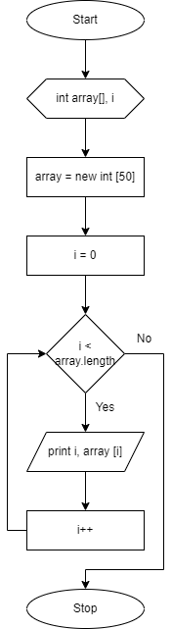

## Assignment 2

